Apache Cassandra Exercise (Sparkify Music Streaming)

1. Objective
To perform Cassandra data modeling by creating a keyspace, creating query-specific tables, inserting sample data, executing queries, demonstrating UPSERT behavior, and verifying consistency levels using CQL.

2. Procedure
1. Open cqlsh and create the 'sparkify' keyspace.
2. Use the sparkify keyspace.
3. Create three tables optimized for three different queries.
4. Insert sample records into each table.
5. Verify the tables and inserted data.
6. Execute Query 1, Query 2 and Query 3.
7. Insert an additional record.
8. Demonstrate UPSERT by inserting a row with an existing primary key.
9. Check and change the consistency level.
10. Exit cqlsh.

3. Source Code

Create Keyspace
CREATE KEYSPACE IF NOT EXISTS sparkify
WITH REPLICATION={'class':'SimpleStrategy','replication_factor':'1'};
USE sparkify;

Create Tables
-- Create song_info_by_session
-- Create song_playing_history_by_user
-- Create who_listened_to_song

Insert Data
INSERT INTO song_info_by_session (...);
INSERT INTO song_playing_history_by_user (...);
INSERT INTO who_listened_to_song (...);

Queries
SELECT * FROM song_info_by_session WHERE session_id=100;
SELECT * FROM song_playing_history_by_user WHERE user_id=1 AND session_id=100;
SELECT * FROM who_listened_to_song WHERE song='Hey Jude';

UPSERT
INSERT INTO song_info_by_session(session_id,item_in_session,artist,song,length)
VALUES(100,1,'The Beatles','Let It Be',4.03);

Consistency
CONSISTENCY;
CONSISTENCY ONE;
EXIT;

4. Screenshots
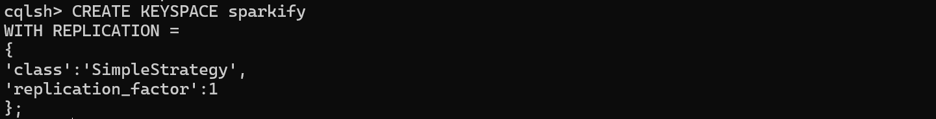
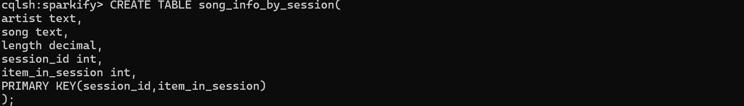
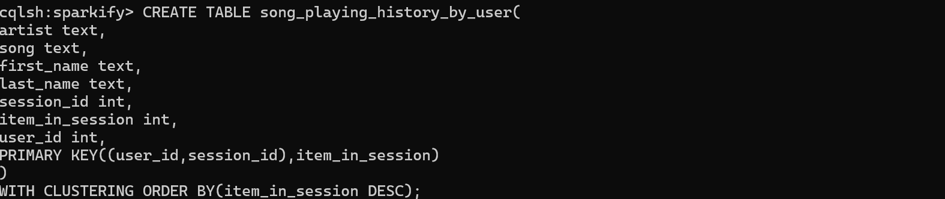
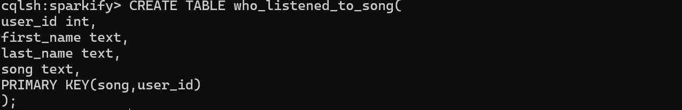
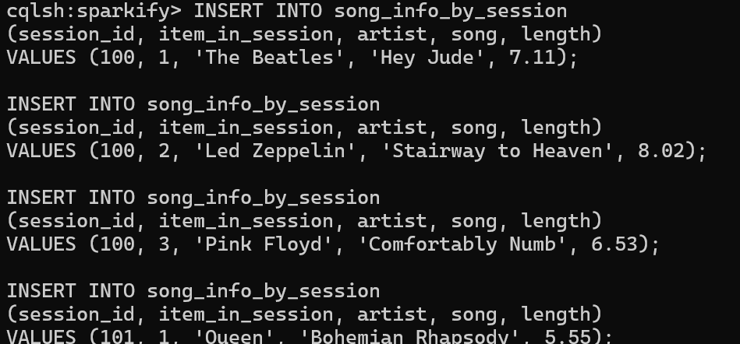
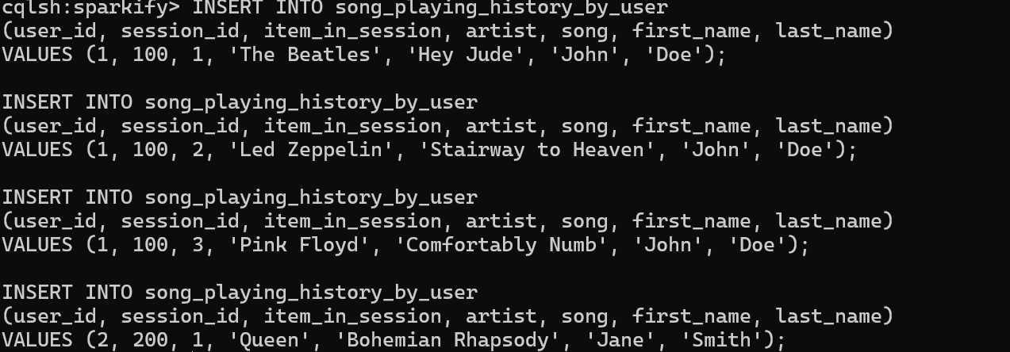
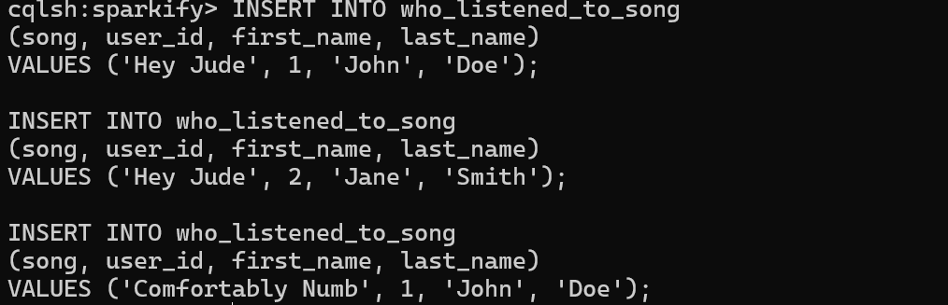
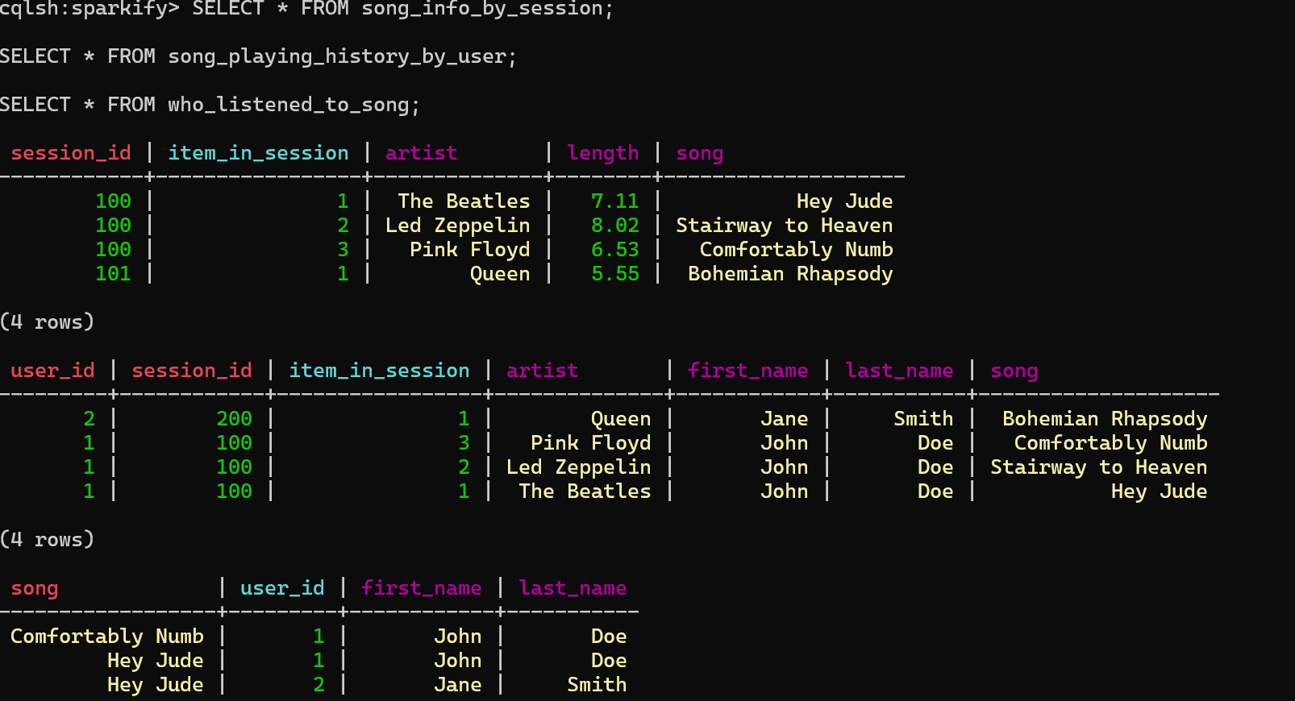
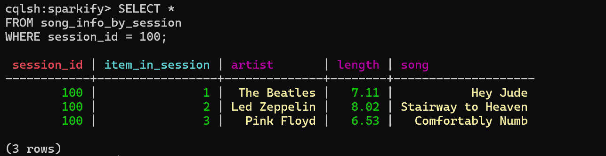
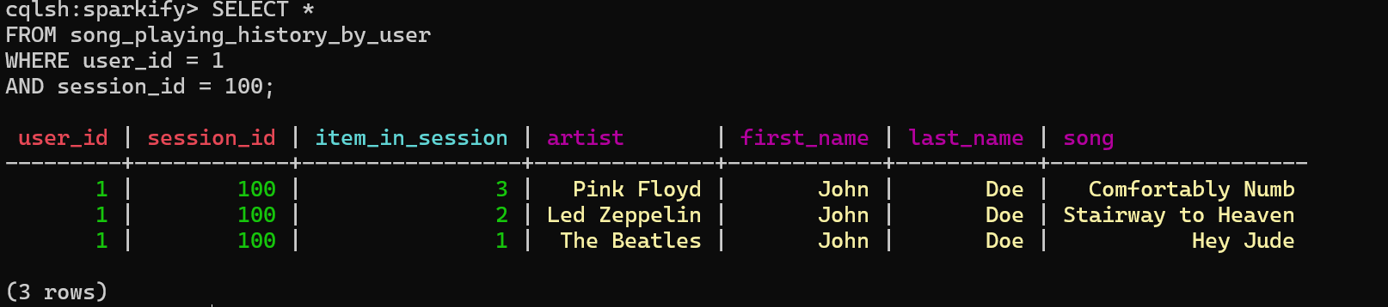
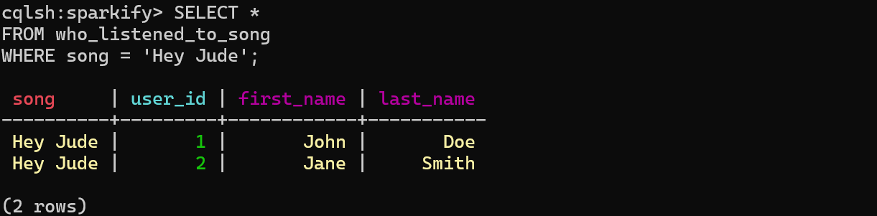
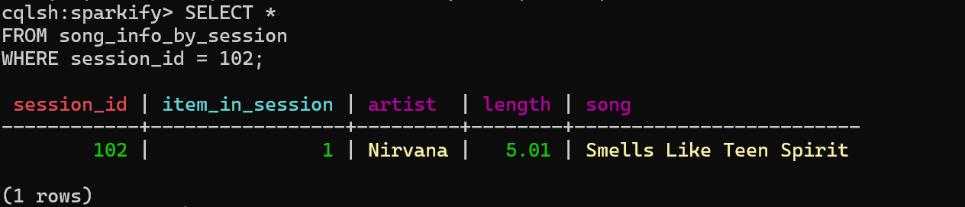
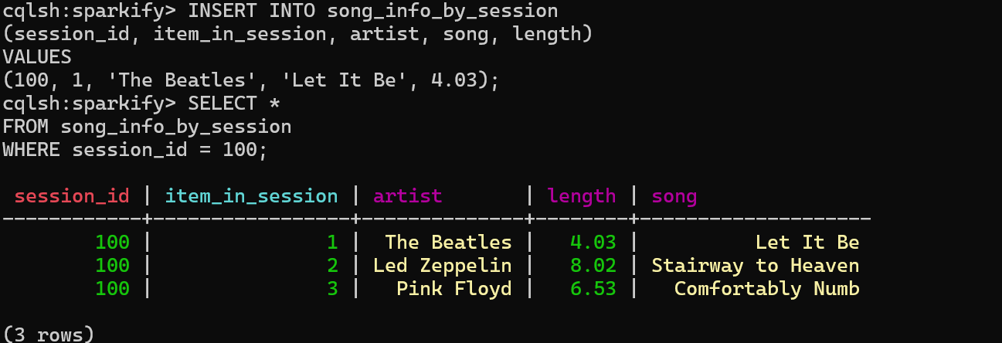

5. Conclusion
The Sparkify Cassandra exercise was completed successfully. A keyspace and query-specific tables were created, sample data was inserted, required queries were executed, UPSERT behavior was verified, and consistency levels were tested. The exercise demonstrated Cassandra's query-driven data modeling approach.

